RESUME
AKSHAY KUMAR DAHAKE
B.E, Mechanical Engineering
Contact No. : - 8087773945
E-mail:- akshaydahake4 @gmail.com

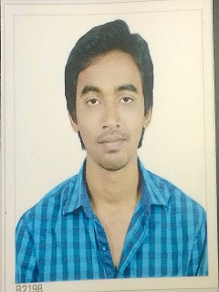
Sai Mouli colony, near govt polytechnic college, fulchur peth , Gondia
Dist– Gondia (M.H)
Pin Code - 481001

CAREER OBJECTIVE
To work in a firm with a professional work driven environment where I can utilize and apply my knowledge, skills which would enable me as a fresh graduate to grow while fulfilling organizational goals.

BASIC ACADEMIC CREDENTIALS

Qualification | University/ Board/Institute | Year | Percentage
B.E(Mechanical) | RGPV BHOPAL,M.P  (SARDAR PATEL COLLEGE OF TECHNELOGY, BALAGHAT ,M.P) | 2011-2015 | 71.4%
Intermediate | MAHAVIR MARWADI JUNIOR COLLGE OF SCIENCE ,GONDIA (M.H) | 2011 | 58.00%
High School | SHREE GANESHAN HIGH SCHOOL , GONDIA (M.H) | 2009 | 69.23%

EXPERIENTIAL LEARNING (SUMMER INTERNSHIP PROGRAM)

- Company Name :- MOIL LIMITED BHARVELI, BALAGHAT (M.P.)
- Duration :- 15 Days (4th July’14 to 18th August’14 )

IT PROFICIENCY

- Auto CAD
- Pro-e (Pursuing)

MAJOR PROJECT

- “smart train” improving the performance OF TRAIN by using wind turbine, solar panel and modified toilet.
Description – The main object of this project is to improve the performance of train and keep platform clean by using some accessories like solar panel, wind turbine and modified toilet. Solar panel and wind turbine generate the energy from sun and wind and modified toilet provides the facility to use toilet , when train stop at platform without dirt on platform.
MINOR PROJECT

- power development from a moving train
Description -In this project kinetic energy of wind is used to generate electricity, by which extra electricity can be generate and supply to train. It can be achieve by fixing wind turbines on train’s coach.

INTERPERSONAL SKILL

  - Ability to rapidly build relationship and set up trust.
  - Confident and Determined.

PERSONAL DETAILS
- Date of Birth :- 24 April 1993
- Language Known :- English & Hindi
- Interest & Hobbies :- Photography, playing chess

DECLARATION

I do hereby declare that the above information is true to the best of my knowledge.

Place: BALAGHAT AKSHAY KUMAR DAHAKE
Date-
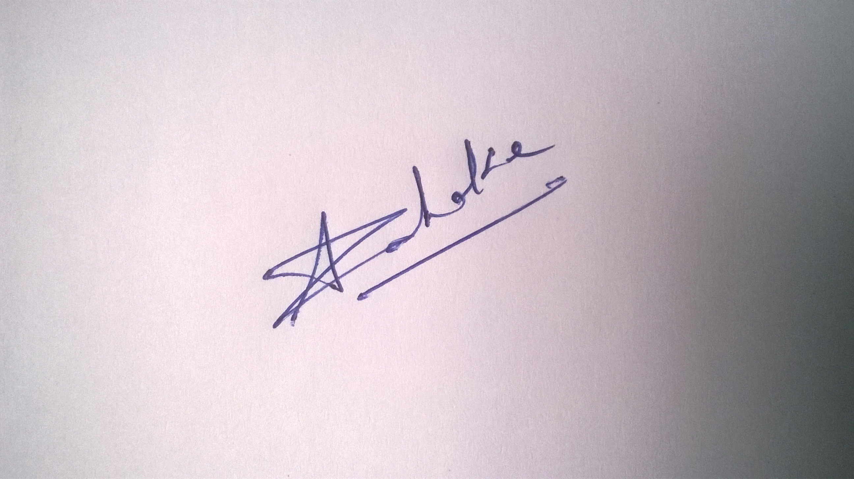

(Signature)

